Ejercicios Sección 2.1

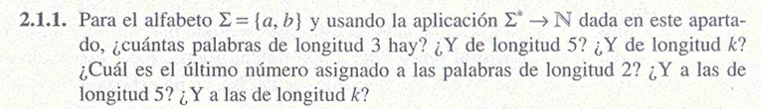
L = {a, b} = {1, 2}
L = {11, 12, 22, 1212, 121212, 12121212, 1212121212}

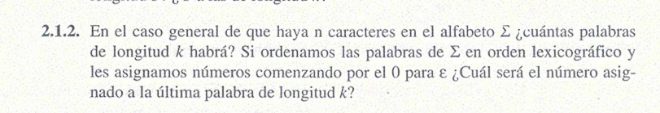
Σ = {ɛ, a, b, c, d, e} = {0, 1, 2, 3, 4, 5} longitud k = 5

Σ = {0, 11, 12, 13, 14, 15, 112, 112, 114, 115, 1112, 1113, 1114, 1115, 11111, 11112, 11113, 11113, 11114, 11115} El ultimo numero seria 5 = e

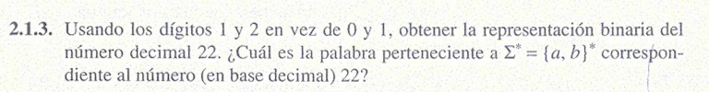
22₁₀ = 10110

ɛ = 0
a = 1
b = 2
aa = 11
ab = 12 aɛaaɛ = por lo tanto la palabra seria aaa
bb = 22
aab = 112
abb = 122
aaab = 1112
bbbb = 2222

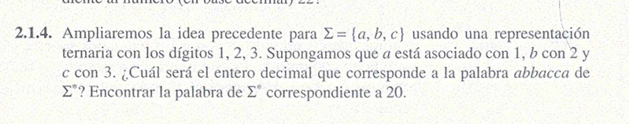

a 1
b 2
c 3
aaa 111 = 4
bbb 222 = 5
ccc 333 = 6
abc 123 = 7
abb 122 = 8
acc 133 = 9
bbc 223 = 10
ccb 332 = 11
aabc 1123 = 12 abbacca = 1221331 = 8+9+1 = 18
aacc 1133 = 13
abbc 1223 = 14
bbcc 2233 = 15
aaabc 11123 = 16
aaabb 11122 = 17
abbacca 1221331 = 18
bbbcc 22233 = 19
cccbb 333bb = 20

